Clock Gating

Introduction: -
Clock Gating is the most popular and effective method to reduce dynamic power consumption by switching the clock off in idle duration of the block

Block Interface
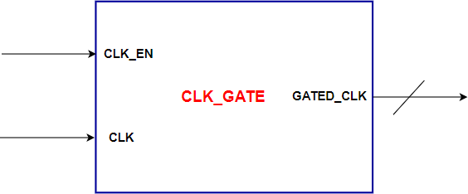

Ports Description

Width | Description | Signal Name
1 | Clock Signal | CLK
1 | Clock Enable | CLK_EN
1 | Gated Clock signal | GATED_CLK

Requirements: -

Write a Verilog Code of the above specifications

